RINKESHKUMAR PATEL rinkeshp77@gmail.com
Mob: +91 9662353777
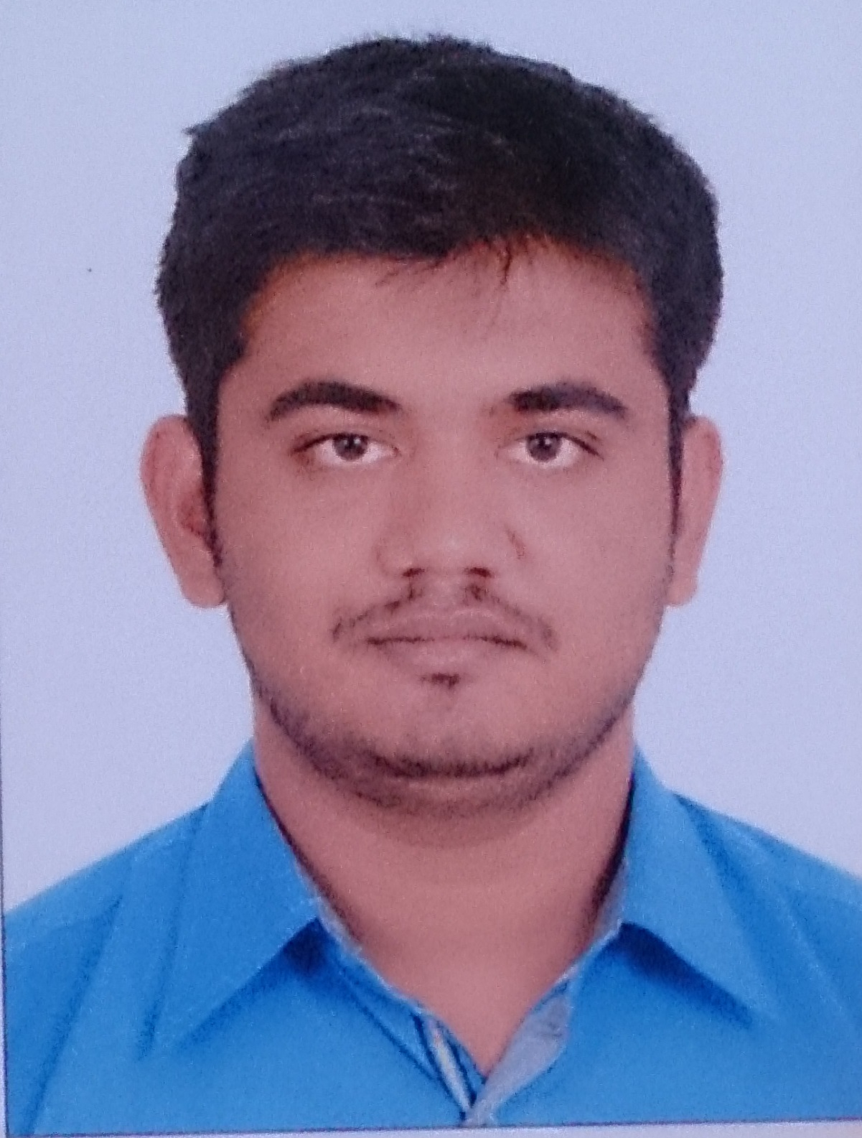

Blog: sureprogram@blogspot.in
Pursuing “Embedded systems Training Course” From Vector India
Pvt. Ltd. at Bangalore since oct-2015
OBJECTIVE

To achieve high carrier growth through a continuous learning process and keep myself dynamic, visionary and competitive with the changing scenario of the world

KEY SKILLS
- C ,C++
- Assembly in 8085,8086, 8051
- System Programming in Linux,
- Image Processing in MATLB
EDUCATIONAL PROFILE
Name of Examination | College | University | Year of passing | Marks Obtained | Class
M.E  (Communication Engineering) | G. H. Patel College of Engineering and Technology  V. V. Nagar | Gujarat Technological University | 2014 | 8.38 CPI | Distinction
B.E  (Electronics &Telecomm) | D. N. Patel College of Engineering  Shahada | North Maharashtra University. Jalgaon | 2012 | 71.86% | Distinction
H.S.C. | S. G. High school Valod | Gujarat State Board  (GHSEB) | 2008 | 62.5% | First
S.S.C. | R. V. Patel  High school Bajipura | Gujarat State Board  (GHSEB) | 2006 | 81.57% | Distinction
Project & Dissertation
- UG Level:
  - Project on “Industrial Farming” In this system automated bird farm controlled using controller 89s52 to control temperature, food dispatch and water supply period with model structure.
  - Component: 89s51, Temperature sensor(LM35), Motor Driver(L293D), BC457, MAX232
  - First Rank In Project Exhibition Organized under ISTE Student Chapter.
- PG Level:
  - Dissertation on “Content Based Image Retrieval for CT Medical images using Support Vector Machine Classifier ”
  - Software: Image Processing in MATLAB 13.
PUBLICATIONS
- Content Based Image Retrieval for Computed tomography images using Support Vector Machine Classifier- IEEE Xplore ISBN 978-1-4799-6985-2
- CBIR for CT Images using SVM- IJSRD Journal (online) ISSN: 2361-0613

KNOWLEDGE OF TECHNICAL SOFTWARE
- Matlab
- Keil µVision IDE
- 8085 IDE simulator
- Xilinx and Quartus
PERSONAL INFORMATION

Full Name : Patel Rinkeshkumar Hasmukhbhai.
Permanent Address : At & Po: Buhari
: 79-80, Shivnagar Society,
: Ta-Valod, Di: Tapi 394630,
Date of Birth : 22/06/1991
Gender : Male
Marital Status : Unmarried
Nationality : Indian
Languages Known : English, Hindi and Gujarati
EXPERIENCE
Worked as a Lecturer at B.V.M Engineering College from October 2013 – August 2015
REFERENCES

1. Dr. D. G. Thakore
H.O.D (Computer Department),
B.V.M Engineering College V. V. Nagar,
Email: dgthakore@bvmengneering.ac.in
Contact No.9825272963
2. Prof. S. K. Parmar
Assistant Professor, EC department,
G.H. Patel College of Engineering & Technology V. V. Nagar
Email: shankarparmar@gcet.ac.in
Contact No: 9824916667

DECLARATION

I hereby declare that the above written particulars are true to the best of my knowledge and belief.
Place:
Date:

_____________________
RINKESH H.PATEL

